CST 226 CLC Project Doctors Office

# ConnectionString Class

This class contains the connection string for the DB that runs the entire application. Here you will update the string based on where you have the database saved in order to run the application.

public static string Conn

Get and Set for the connection string

# Login Form

The login form is a simple form that has the title of the program, a username, and password textbox and a login button. This is where the user will enter their credentials in order to login to the application

# Main_Menu Form

This form is the main form that all users regardless of their permission level will have access to. The forms available to the user will be based on their privilege level. The user can open the forms within the MDI. This allows the user to open up multiple forms at one time and minimize them all in one place.

public Main_Menu(String username, Boolean cForm, Boolean oForm, Boolean aForm, Boolean mForm)

Assigns Boolean values enabling or disabling access to certain forms based on what permission group the user belongs to.

private void ExitToolsStripMenuItem_Click(object sender, EventArgs e)

Closes out of the MDI

private void clericalFormToolStripMenuItem_Click(object sender, EventArgs e)

Opens the Clerical Form

private void printToolStripMenuItem_Click(object sender, EventArgs e)

Opens the print menu to select a printer and print the contents of the application screen.

Private void invoiceReportToolStripMenuItem_Click

Opens the Patients_Invoices report

# UserControl1

This form is what tracks patient information such as their address, DOB, age, insurance, gender, diseases, allergies, medications, and so on. This form also allows the user to add a new patient to the database.

cboSelectTestResult_SelectedIndexChanged

Gets the patients test results based on what test the user selects. It will also display the percentage of patients with the same test result as the patient.

private void getTestResultsPercentage(String tType)

This method works with the cboSelectTestResult_SelectedIndexChanged method. It prevents redundancy by calling out to this method with the test type being performed to grab the appropriate data for the user.

# Reports Form

Void Button_Run_Click()

Calls several other methods:

GetPatientReport();

GetPatientID();

GetPatientXRays();

Void Main_Click()

Opens a new UserControl1 form

Public Reports()

Assigns the connection string value

Void btnCreateXray_Click()

Calls the Patient Xray form if the Patient Number is not null or displays an error

Void GetPatientID()

Pulls PatientNumber from the OutPatients Table

Void GetPaidReport()

Grabs all fields from the TestResults table

Void GetPatientXrays()

Pulls the XRay_ID and Xray_Title from Patient_Xrays to assign the cboXrayImages combobox

Void btnOpenXray()

Opens a new instance of Patient_Xray only if the user selects an existing X-Ray for the patient from the combobox. Displays an error if the selected index of the combobox is -1

# Patient_Xray Form

Public Patient_Xray (String)

This method is called if this is a new Xray. Only pulls Patient Number from Reports form.

Public Patient_Xray (String, String)

This method is called if this is an existing Xray. Pulls Patient Number and Xray_ID from Reports form.

Void btnBrowse_Click()

This method opens a file explorer so that you can search for an image and assigns it to the txtXrayImageLoc textbox

Void Patient_Xray_Load()

This method loads the XRayTypes combobox with all the fields in the DB and pre selects the index based on the Xray record passed to the form

Void btnBack()

This method hides the Patient_Xray form and shows the reports form

Void btnSave_Click()

This method either saves or updates an Xray record and checks to ensure that all fields have data prior to saving the record

Void GetPatientXray(String, String)

This method pulls an existing patient_Xrays record and displays it in the form

Void CreateNewPatientXray(String)

This method creates a new record in the Patient_Xrays table and returns the new ID for the table and assigns it to the lblXrayID field

Void UpdatePatientXray()

This method updates an existing Patient_Xrays record

Void btnNew_Click()

This method sets all of the fields on the form to empty so that a new record can be created for the patient

Boolean isEmpty()

Checks all fields to see if they are empty and returns either true (is empty) or false (is not empty)

# Patients_Invoices

Void btnSearch_Click()

Clears all existing data in the datagrid view, runs the searchoption() method, and clears all of the form fields by calling the ClearFields() method.

Void SearchByPatientName()

Pulls data from OurPatients, Patient_Invoices, and Insurance_Types to add to the datagridview based on the patients first or last name

SearchByPatientNameAndDate()

This method Pulls data from OurPatients, Patient_Invoices, and Insurance_Types to add to the datagridview based on the patients first or last name and date range selected

SearchAllRecordsByDate()

This method Pulls data from OurPatients, Patient_Invoices, and Insurance_Types to add to the datagridview based on a date range

SearchOption()

This method calls the appropriate method when the Search button is clicked based of the fields with data in them (date time pickers, text field)

dtpPatientFrom_ValueChanged()

This method tracks if data was changed in the date time picker and shows a checkbox to show that it has.

dtpPatientTo_ValueChanged()

This method tracks if data was changed in the date time picker and shows a checkbox to show that it has.

ClearFields()

This method changes the date time pickers to not show the checkbox and also clears the PatientName text field

dgvInvoices_CellContentClick()

This method calls the appropriate method based on which button was clicked and for which row in the datagrid view. It calls the DeleteInvoice or Email Methods.

DeleteInvoices()

This method is passed the invoiceID and row index of the row selected in the datagridview where the Delete button was pressed. It deletes the record from the invoices table and removes the record from the datagridview.

Email()

This method pulls the email address for the patient and insurance company, and balances due for the invoice. It then displays a message box showing that emails were sent to the insurance company and or patient if they have a balance due for the invoice.

# MedOffice 1.0 Class Diagram

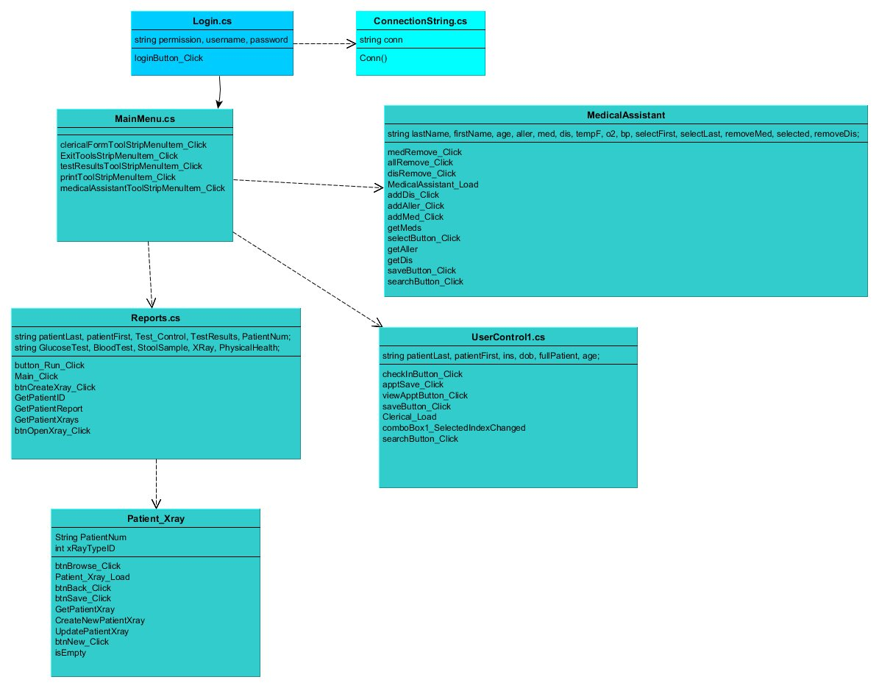

# MedOffice 1.0 Use Cases

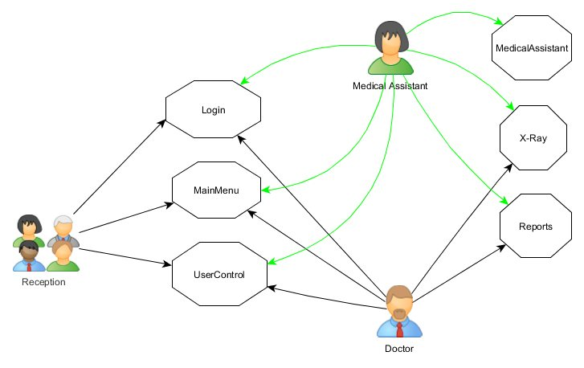

# MedOffice 1.0 State Diagram

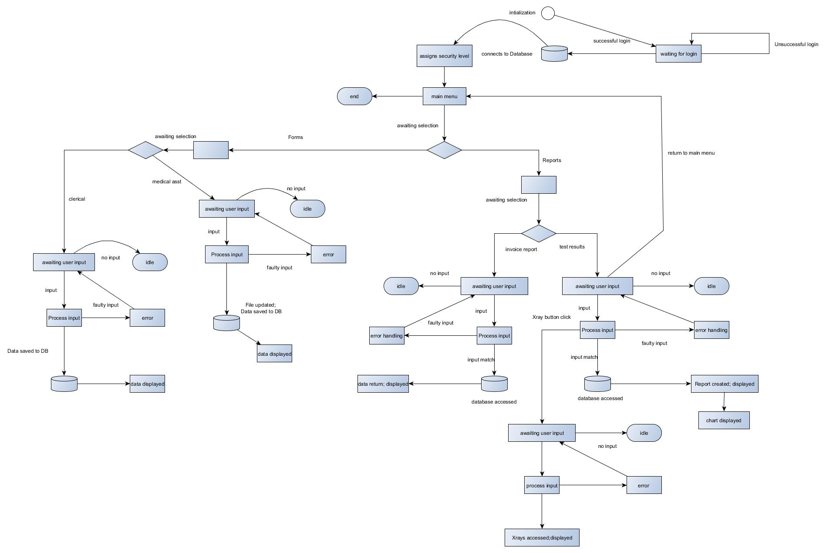

MedOffice 1.0 Activity Diagram

# 

MedOffice 1.0 Interaction Diagram

